QUESTION 1

View the Exhibit and examine the data in the PROMOTIONS table.

PROMO_BEGIN_DATE is stored in the default date format, dd-mon-rr.

You need to produce a report that provides the name, cost, and start date of all promos in the POST category that were launched before January 1, 2000.

Which SQL statement would you use?

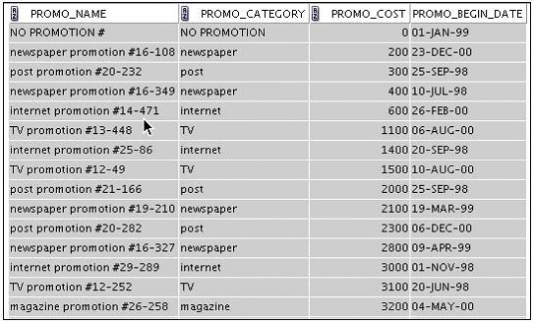

A. | SELECT promo_name, promo_cost, promo_begin_date  FROM promotions  WHERE promo_category = 'post' AND promo_begin_date < '01-01-00';
B. | SELECT promo_name, promo_cost, promo_begin_date  FROM promotions  WHERE promo_cost LIKE 'post%' AND promo_begin_date < '01-01-2000';
C. | SELECT promo_name, promo_cost, promo_begin_date  FROM promotions  WHERE promo_category LIKE 'P%' AND promo_begin_date < '1-JANUARY-00';
D. | SELECT promo_name, promo_cost, promo_begin_date  FROM promotions  WHERE promo_category LIKE '%post%' AND promo_begin_date < '1-JAN-00';

QUESTION 2
View the Exhibit and examine the data in the PROMOTIONS table. PROMO_BEGIN_DATE is stored in the default date format, dd-mon-rr.

You need to produce a report that provides the name, cost, and start date of all promos in the POST category that were launched before January 1, 2000. Which SQL statement would you use?

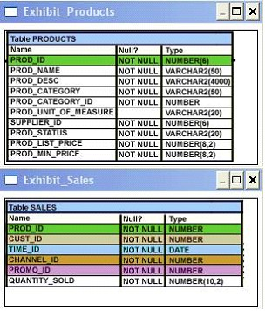

A. | SELECT promo_name, promo_cost, promo_begin_date  FROM promotions  WHERE promo_category = 'post' AND promo_begin_date < '01-01-00';
B. | SELECT promo_name, promo_cost, promo_begin_date  FROM promotions  WHERE promo_cost LIKE 'post%' AND promo_begin_date < '01-01-2000';
C. | SELECT promo_name, promo_cost, promo_begin_date  FROM promotions  WHERE promo_category LIKE 'P%' AND promo_begin_date < '1-JANUARY-00';
D. | SELECT promo_name, promo_cost, promo_begin_date  FROM promotions  WHERE promo_category LIKE '%post%' AND promo_begin_date < '1-JAN-00';

QUESTION 3
Evaluate the following DELETE statement:

DELETE FROM sales;

There are no other uncommitted transactions on the SALES table.

Which statement is true about the DELETE statement?

A. | It would not remove the rows if the table has a primary key.
B. | It removes all the rows as well as the structure of the table.
C. | It removes all the rows in the table and deleted rows can be rolled back.
D. | It removes all the rows in the table and deleted rows cannot be rolled back.

QUESTION 4

Which three statements are true about multiple-row subqueries? (Choose three.)

A. | They can contain a subquery within a subquery.
B. | They can return multiple columns as well as rows.
C. | They cannot contain a subquery within a subquery.
D. | They can return only one column but multiple rows.
E. | They can contain group functions and GROUP BY and HAVING clauses.
F. | They can contain group functions and the GROUP BY clause, but not the HAVING clause.

QUESTION 5
Examine the description of the EMP_DETAILS table given below:

NAME NULL TYPE
----------------- ----------------- --------------------------- EMP_ID NOT NULL NUMBER
EMP_NAME NOT NULL VARCHAR2 (40)

EMP_IMAGE LONG

Which two statements are true regarding SQL statements that can be executed on the EMP_DETAIL table? (Choose two.)

A. | An EMP_IMAGE column can be included in the GROUP BY clause.
B. | An EMP_IMAGE column cannot be included in the ORDER BY clause.
C. | You cannot add a new column to the table with LONG as the data type.
D. | You can alter the table to include the NOT NULL constraint on the EMP_IMAGE column.

QUESTION 6

View the Exhibits and examine PRODUCTS and SALES tables.

You issue the following query to display product name and the number of times the product has been sold:

SQL>SELECT p.prod_name, i.item_cnt
FROM (SELECT prod_id, COUNT(*) item_cnt
FROM sales
GROUP BY prod_id) i RIGHT OUTER JOIN products p
ON i.prod_id = p.prod_id;

What happens when the above statement is executed?

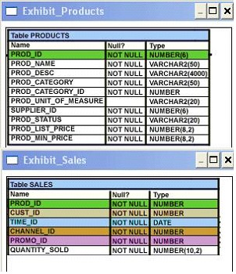

A. | The statement executes successfully and produces the required output.
B. | The statement produces an error because ITEM_CNT cannot be displayed in the outer query.
C. | The statement produces an error because a subquery in the FROM clause and outer-joins cannot be used together.
D. | The statement produces an error because the GROUP BY clause cannot be used in a subquery in the FROM clause.

QUESTION 7
Examine the structure and data of the CUST_TRANS table:

CUST_TRANS

Name Null? Type
------- -------------- -------

CUSTNO NOT NULL CHAR(2)

TRANSDATE DATE

TRANSAMT NUMBER(6,2)

CUSTNO TRANSDATE TRANSAMT
------------ ---------------- ----------------
11 01-JAN-07 1000
22 01-FEB-07 2000
33 01-MAR-07 3000

Dates are stored in the default date format dd-mon-rr in the CUST_TRANS table.

Which three SQL statements would execute successfully? (Choose three.)

A. | SELECT transdate + '10' FROM cust_trans;
B. | SELECT * FROM cust_trans WHERE transdate = '01-01-07';
C. | SELECT transamt FROM cust_trans WHERE custno > '11';
D. | SELECT * FROM cust_trans WHERE transdate='01-JANUARY-07';
E. | SELECT custno + 'A' FROM cust_trans WHERE transamt > 2000;

QUESTION 8

View the Exhibit and examine the structure of the CUSTOMERS and CUST_HISTORY tables.

The CUSTOMERS table contains the current location of all currently active customers. The CUST_HISTORY table stores historical details relating to any changes in the location of all current as well as previous customers who are no longer active with the company.

You need to find those customers who have never changed their address.

Which SET operator would you use to get the required output?

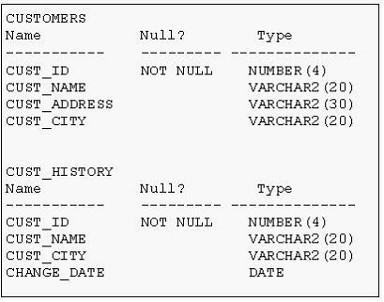

A. | MINUS
B. | UNION
C. | INTERSECT
D. | UNION ALL

QUESTION 9

View the Exhibit and examine the description for the CUSTOMERS table.

You want to update the CUST_CREDIT_LIMIT column to NULL for all the customers, where CUST_INCOME_LEVEL has NULL in the CUSTOMERS table. Which SQL statement will accomplish the task?

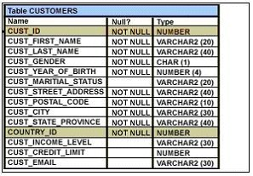

A. | UPDATE customers  SET cust_credit_limit = NULL  WHERE CUST_INCOME_LEVEL = NULL;
B. | UPDATE customers  SET cust_credit_limit = NULL  WHERE cust_income_level IS NULL;
C. | UPDATE customers  SET cust_credit_limit = TO_NUMBER(NULL)  WHERE cust_income_level = TO_NUMBER(NULL);
D. | UPDATE customers  SET cust_credit_limit = TO_NUMBER(' ',9999)  WHERE cust_income_level IS NULL;

QUESTION 10

View the Exhibits and examine the structures of the PRODUCTS, SALES, and CUSTOMERS tables.

You issue the following query:

SQL>SELECT p.prod_id,prod_name,prod_list_price,
quantity_sold,cust_last_name
FROM products p NATURAL JOIN sales s NATURAL JOIN customers c WHERE prod_id =148;

Which statement is true regarding the outcome of this query?

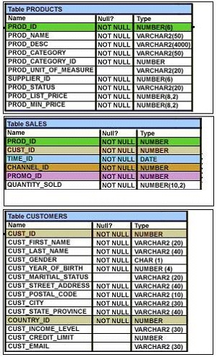

A. | It executes successfully.
B. | It produces an error because the NATURAL join can be used only with two tables.
C. | It produces an error because a column used in the NATURAL join cannot have a qualifier.
D. | It produces an error because all columns used in the NATURAL join should have a qualifier.

QUESTION 11

View the Exhibit and examine the data in the PROMOTIONS table.

You need to display all promo categories that do not have 'discount' in their subcategory.

Which two SQL statements give the required result? (Choose two.)

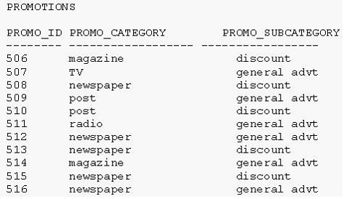

A. | SELECT promo_category  FROM promotions  MINUS  SELECT promo_category  FROM promotions  WHERE promo_subcategory = 'discount';
B. | SELECT promo_category  FROM promotions  INTERSECT  SELECT promo_category  FROM promotions  WHERE promo_subcategory = 'discount';
C. | SELECT promo_category  FROM promotions  MINUS  SELECT promo_category  FROM promotions  WHERE promo_subcategory <> 'discount';
D. | SELECT promo_category  FROM promotions  INTERSECT  SELECT promo_category  FROM promotions  WHERE promo_subcategory <> 'discount';

QUESTION 12
The PRODUCTS table has the following structure:

Name Null? Type
--------- ---------- -------------

PROD_ID NOT NULL NUMBER(4)

PROD_NAME VARCHAR2(25)

PROD_EXPIRY_DATE DATE

Evaluate the following two SQL statements:

SQL>SELECT prod_id, NVL2(prod_expiry_date, prod_expiry_date + 15,'')FROM products; SQL>SELECT prod_id, NVL(prod_expiry_date, prod_expiry_date + 15) FROM products;

Which statement is true regarding the outcome?

A. | Both the statements execute and give different results.
B. | Both the statements execute and give the same result.
C. | Only the first SQL statement executes successfully.
D. | Only the second SQL statement executes successfully.

QUESTION 13

View the Exhibit and examine the structure of CUSTOMERS and GRADES tables.

You need to display names and grades of customers who have the highest credit limit.

Which two SQL statements would accomplish the task? (Choose two.)

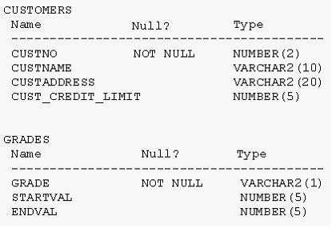

A. | SELECT custname, grade  FROM customers, grades  WHERE (SELECT MAX(cust_credit_limit)  FROM customers) BETWEEN startval and endval;
B. | SELECT custname, grade  FROM customers, grades  WHERE (SELECT MAX(cust_credit_limit)  FROM customers) BETWEEN startval and endval  AND cust_credit_limit BETWEEN startval AND endval;
C. | SELECT custname, grade  FROM customers, grades  WHERE cust_credit_limit = (SELECT MAX(cust_credit_limit)  FROM customers)  AND cust_credit_limit BETWEEN startval AND endval;
D. | SELECT custname, grade  FROM customers, grades  WHERE cust_credit_limit IN (SELECT MAX(cust_credit_limit)  FROM customers)  AND MAX(cust_credit_limit) BETWEEN startval AND endval;

QUESTION 14

View the Exhibit and examine the structure of the CUSTOMERS table.

Using the CUSTOMERS table, you need to generate a report that shows the average credit limit for customers in WASHINGTON and NEW YORK.

Which SQL statement would produce the required result?

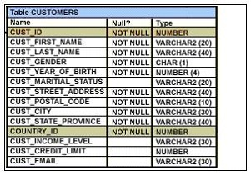

A. | SELECT cust_city, AVG(cust_credit_limit)  FROM customers  WHERE cust_city IN ('WASHINGTON','NEW YORK')  GROUP BY cust_credit_limit, cust_city;
B. | SELECT cust_city, AVG(cust_credit_limit)  FROM customers  WHERE cust_city IN ('WASHINGTON','NEW YORK')  GROUP BY cust_city,cust_credit_limit;
C. | SELECT cust_city, AVG(cust_credit_limit)  FROM customers  WHERE cust_city IN ('WASHINGTON','NEW YORK')  GROUP BY cust_city;
D. | SELECT cust_city, AVG(NVL(cust_credit_limit,0))  FROM customers  WHERE cust_city IN ('WASHINGTON','NEW YORK');

QUESTION 15
You want to create an ORD_DETAIL table to store details for an order placed having the following business requirement:

1) The order ID will be unique and cannot have null values.
2) The order date cannot have null values and the default should be the current date.
3) The order amount should not be less than 50.
4) The order status will have values either shipped or not shipped.
5) The order payment mode should be cheque, credit card, or cash on delivery (COD).

Which is the valid DDL statement for creating the ORD_DETAIL table?

A. | CREATE TABLE ord_details  (ord_id NUMBER(2) CONSTRAINT ord_id_nn NOT NULL,  ord_date DATE DEFAULT SYSDATE NOT NULL,  ord_amount NUMBER(5, 2) CONSTRAINT ord_amount_min  CHECK (ord_amount > 50),  ord_status VARCHAR2(15) CONSTRAINT ord_status_chk  CHECK (ord_status IN ('Shipped', 'Not Shipped')),  ord_pay_mode VARCHAR2(15) CONSTRAINT ord_pay_chk  CHECK (ord_pay_mode IN ('Cheque', 'Credit Card',  'Cash On Delivery')));
B. | CREATE TABLE ord_details  (ord_id NUMBER(2) CONSTRAINT ord_id_uk UNIQUE NOT NULL,  ord_date DATE DEFAULT SYSDATE NOT NULL,  ord_amount NUMBER(5, 2) CONSTRAINT ord_amount_min  CHECK (ord_amount > 50),  ord_status VARCHAR2(15) CONSTRAINT ord_status_chk  CHECK (ord_status IN ('Shipped', 'Not Shipped')),  ord_pay_mode VARCHAR2(15) CONSTRAINT ord_pay_chk  CHECK (ord_pay_mode IN ('Cheque', 'Credit Card',  'Cash On Delivery')));
C. | CREATE TABLE ord_details  (ord_id NUMBER(2) CONSTRAINT ord_id_pk PRIMARY KEY,  ord_date DATE DEFAULT SYSDATE NOT NULL,  ord_amount NUMBER(5, 2) CONSTRAINT ord_amount_min  CHECK (ord_amount >= 50),  ord_status VARCHAR2(15) CONSTRAINT ord_status_chk ord_status VARCHAR2(15)  CONSTRAINT ord_status_chk  CHECK (ord_status IN ('Shipped', 'Not Shipped')),  ord_pay_mode VARCHAR2(15) CONSTRAINT ord_pay_chk ord_pay_mode VARCHAR2(15)  CONSTRAINT ord_pay_chk  CHECK (ord_pay_mode IN ('Cheque', 'Credit Card',  'Cash On Delivery')));
D. | CREATE TABLE ord_details  (ord_id NUMBER(2),  ord_date DATE NOT NULL DEFAULT SYSDATE,  ord_amount NUMBER(5, 2) CONSTRAINT ord_amount_min  CHECK (ord_amount >= 50),  ord_status VARCHAR2(15) CONSTRAINT ord_status_chk  CHECK (ord_status IN ('Shipped', 'Not Shipped')),  ord_pay_mode VARCHAR2(15) CONSTRAINT ord_pay_chk  CHECK (ord_pay_mode IN ('Cheque', 'Credit Card',  'Cash On Delivery')));

